**Aneurysm Metrics User Interface Instructions**

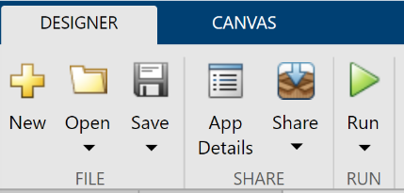

**Running the Interface and Loading Data:**

1. Run MATLAB app by clicking the green run arrow found in the toolstrip.
2. Click the “Import Image” button on the left side of the interface.
3. Select the two nifi data files – the brain and the mask.
   1. A file explorer window will open. Navigate to and select the nifti file that corresponds with the entire brain. Click Open.
   2. Another file explorer window will open. Navigate to and select the nifty file that corresponds with the mask. Click Open.
4. Wait for MATLAB to run and the interface to populate. This may take up to BLANK seconds.
5. The images can be manipulated (zoom, pan, etc.) by hovering the mouse over the top right corner of the image for a toolbar to appear.
   1. 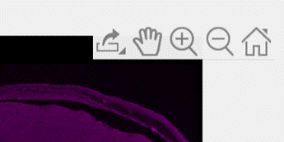To use a tool, select the symbol for it (the symbol will become blue). Then click and use the tool on the image.
      1. Pan or Drag: hand symbol
      2. Zoom: plus and minus magnifying glass symbol
6. To import a new dataset, click the “Import Image” button.

**Navigating the Displayed Information:**

* Image Metrics are displayed on the left side of the Interface.
  + **BV. Max. Diameter:** The maximum diameter of the blood vessel.
  + **AN. Max. Diameter:** The maximum diameter of the aneurysm.
  + **Size Ratio:** The size ratio between the max diameter of the blood vessel and the aneurysm.
* Images
  + **Whole Brain Image:** Displays the view of the entire brain scan with the aneruysm. The aneurysm is highlighted green but may need to be zoomed in to see it.
  + **Aneurysm and Vessel Image:**